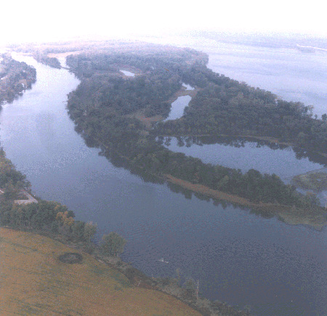

47
DRESSER ISLAND

HABITAT REHABILITATION AND ENHANCEMENT PROJECT

Pool 26
Upper Mississippi River Miles 206-209

St. Charles County, Missouri
St. Louis District

RESOURCE PROBLEM:

The habitat of this State-managed federally owned fish and wildlife area had deteriorated due to the effects of flood-induced sediment deposition. Attempts to grow food for wildlife had been unsuccessful because of interior water level fluctuations.
PROJECT FEATURES:

- Construct low levee (28,250 feet long) to encircle most of Dresser Island with connections crossing upper Brickhouse Slough to high ground on the Missouri mainland; and

- Install gated drains for water release and control of interior water levels.

PROJECT OUTPUTS:

Preliminary results indicate that the desired water temperature control is being achieved. In addition, interior water levels were maintained independent of river stage, with only a 1-foot variance, which will allow for the development of moist-soil plant production during future growing seasons.

FINANCIAL DATA:

General design costs were $285,000, and construction costs were $2,600,000. Annual costs for operation, maintenance, and repair are estimated at $16,400 and are the responsibility of the non-Federal sponsor, the Missouri Department of Conservation.

STATUS:

Construction was completed in September 1991. The project is being operated by the Missouri Department of Conservation.

